Table S1. Feeding schedule and dietary composition of captive felids at the participating facilities.
Day | Zoo | Safari Park 1 | Safari Park 2
Monday | Dressed chicken | Chicken | Chicken
Tuesday | Dressed chicken | Chicken | Chicken
Wednesday | Beef | Chicken | Fasting
Thursday | Dressed chicken | Chicken | Chicken
Friday | Dressed chicken | Fasting | Chicken
Saturday | Beef | Chicken | Fasting
Sunday | Fasting | Chicken | Chicken
Feeding time | Once a day, 9 AM | Once a day, 7 to 8 AM | Once a day, 8 AM
Amount per animal | Dressed chicken 4 to 6 kg, beef 2 to 3 kg, by body weight | 5 kg | 5 kg
Zoo, Chattogram Zoo; Safari Park 1, Dulahazara Safari Park; Safari Park 2, Gazipur Safari Park.

Figure S1
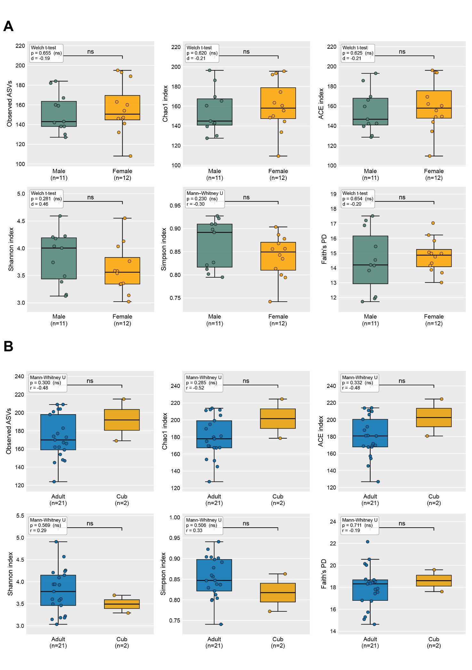
Figure S2


